# **Udemy Project Description**

The Head of Curriculum at Udemy wishes to find the data on course revenue, the data related to the courses from different topics is provided in order to understand where opportunities to increase revenue may lie, and track the performance of courses. Manager has suggested encouraging web development courses to charge more, because they believe that these are the most popular courses.

The main purpose is to increase their next quarter earnings by looking into the course revenue. This can be achieved by finding the total number of subscribers for each subject, reviews and course cost type.

# **Design**

* The dataset consists of four different excel sheets with respect to the subjects, all the sheets were merged together to find the aggregate.
* The data is then cleaned if any duplicates or null values are found. And the subject title which is not same as other title is replaced with the right title by using find and replace function in excel.
* The date is separated from the published timestamp to know only the date of each course being published using “left” function.
* The course is then identified based on the type of its cost that is paid or free course.
* VLOOKUP is used to extract the top 20 most subscribed courses with their levels, course type(free/paid), duration of the course and date published. It helps to understand the trends for the most subscribed courses.
* Pivot Table is used to aggregate the data to know the total number of subscribers for each subject, average number of subscribers for each subject, average cost per subject at each level, average content duration for each subject, and average rating per subject for each level.

# **Findings**

The pie chart shows the total number of subscribers for each subject, which shows web development has more no. of subscribers and musical instruments with the least. And from the bar graph the web development shows the highest average no. of subscribers.

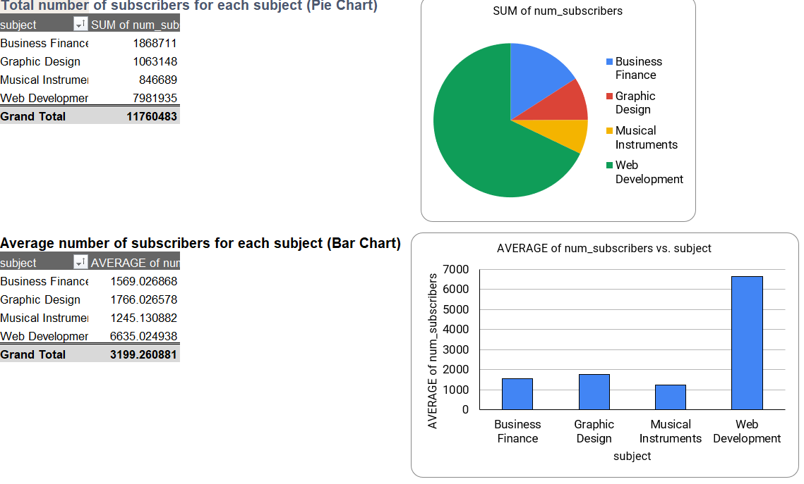

**Figure 1. Pie chart representing total no. of subscribers for each subject and bar graph represents average number of subscribers for each subject**

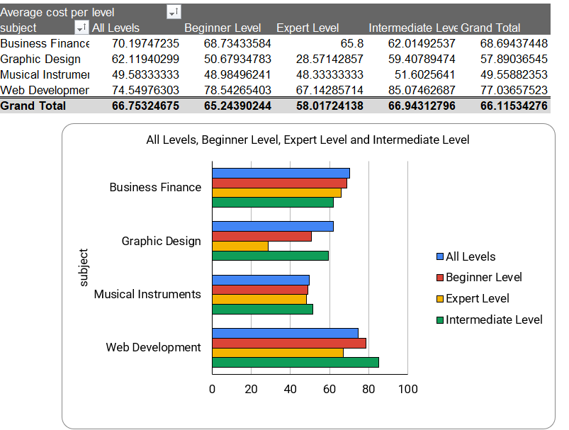

**Figure 2. Bar graph representing average cost for different levels of each subject**

From the above chart average cost per subject at each level, where intermediate and all levels shows the highest average cost with respect to web development and business finance.

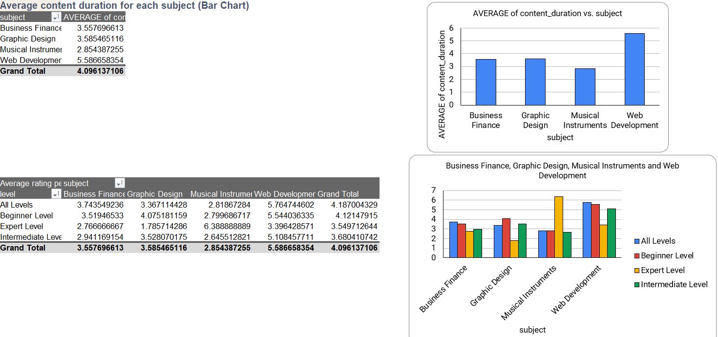

**Figure 3. Bar graph represents average content duration for each subject and column chart representing average rating per subject**

Average content duration of each subject is shown in the bar graph with web development having the highest and musical instrument showing the least.

From average rating per subject at each level, the musical instruments at expert level shows the highest rating compared to web development even with more no. of subscribers.

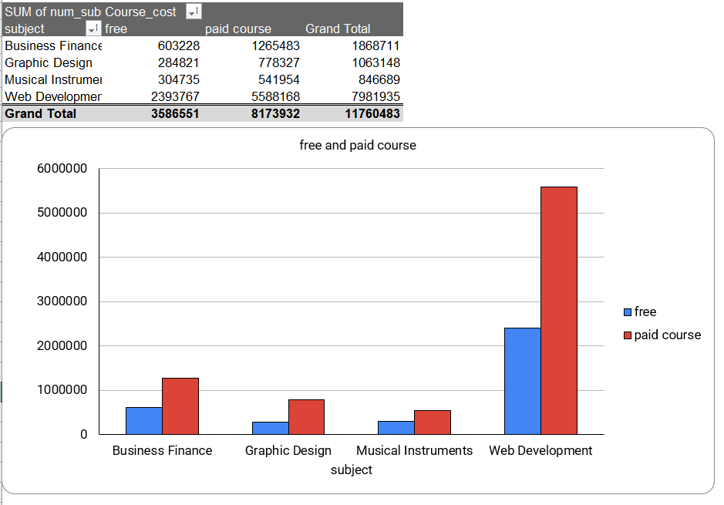

**Figure 4. Column chart represents total no. of subscribers for each subject based on free and paid course**

Total no. of subscribers for each subject based on free and paid courses, the web development subject’s paid course is most subscribed and least paid course is for musical instruments. Furthermore, the free course has highest subscribers in web development and least is in graphic design.

**Tabelau Visualization:**

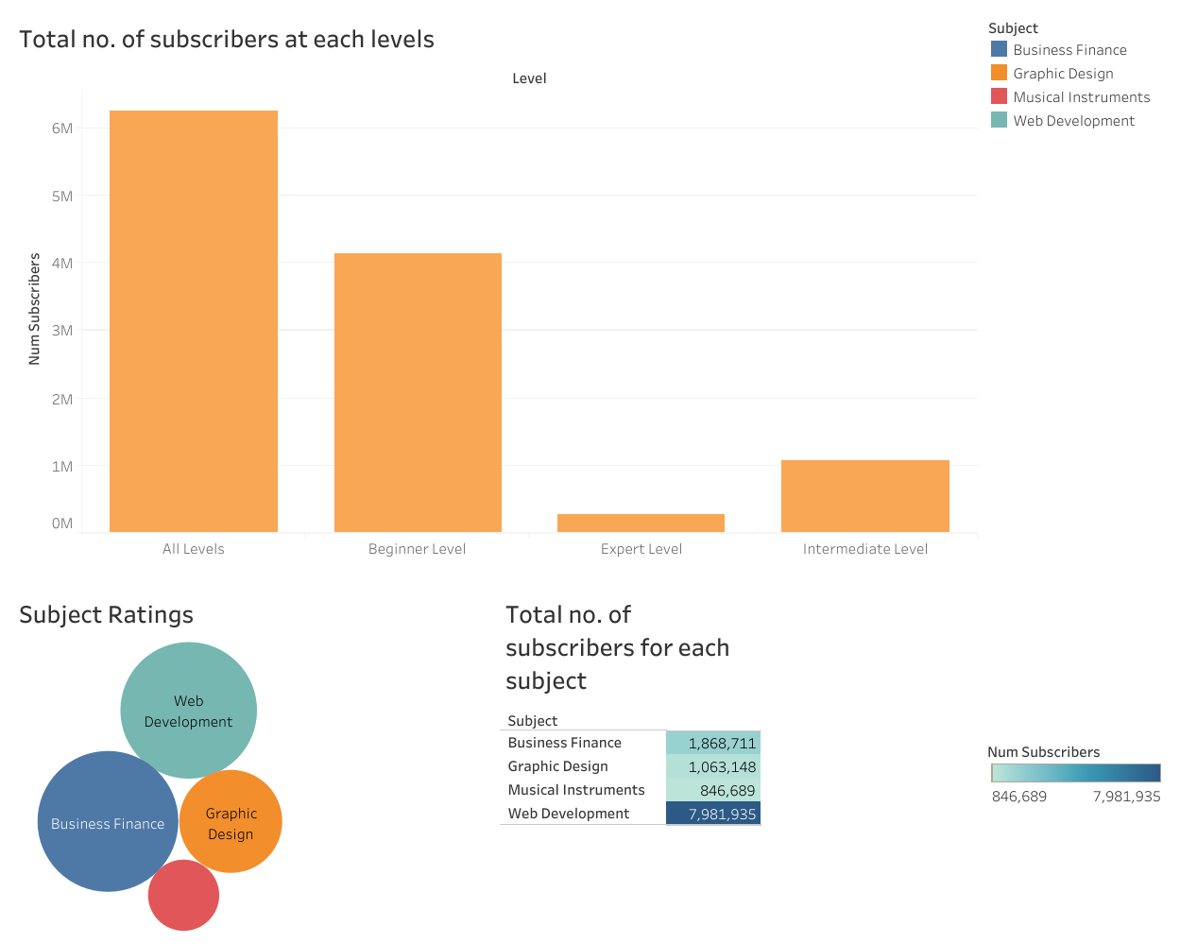

**Figure 5. Dashboard with all the visualizations for the analysis carried out**

From Tabelau visualiztion the dashboard shows various aspects of comparision in terms of charts, the bar graph shows the total no. of subscribers of all subjects at each level , where the web development having the highest no. of subscribers. Subject ratings is shown using bubbles with varying size and and total no. of subscribers of each subject is shown using legends.

**Analysis**

From the dataset being analyzed, the first question that arises is why the revenue is same throughout, in order to find the root cause, the no. of subscribers for each subject, reviews and cost types were analyzed.

Analyzing the dataset in excel, the average no. of subscribers were found to be web development and the least was for musical instrument. The no. of subscribers compared with all the levels, web development was again on top and second highest was business finance. All the levels had same number of subscribers in web development comparatively.

The content duration of web development compared with other subjects it was more and also the rating of all the levels for web development was almost good except expert level. The least rated ones are music instruments.

From Tabelau dashboard, no. of subscribers at each level shows that all levels had highest no. of subscribers and expert level had least. Even the subject ratings shows the same result as of pivot table.

**Conclusion**

The Udemy course analysis shows that the revenue increase is mainly due to web development course being enrolled more, with all the levels being enrolled. From overall analysis the enrolment is based on subject interest and the other subjects like graphic design and musical instruments have very less enrolments.

The revenue can be increased by giving offer to all the subjects and see the levels included in least enrolled subjects to be updated and get more peer reviews from the enrolled members.